March 2018

Dear Tennis Member,

SUBSCRIPTIONS FOR 2018 SEASON

We hope you will be joining us again this year, taking part in our extensive league programme and enjoying our many forthcoming activities (see website / noticeboard for details). As in past years, to help spread the cost you can pay by instalments if you wish (details overleaf).

Please complete pages 4 and 5 of this document for all renewing members and send this together with your remittance to:
BMTC Membership
Derek G Cockayne
Ashcroft
Cliffash Lane
Idridgehay
Belper, Derbyshire DE56 2SJ
Cheques should be made payable to ‘Belper Meadows Tennis Club’. A membership card (and key if requested) will then be posted to you.

Please note:
- Players will only be eligible for league match selection if their membership subscription has been paid.
- If you are a member of another section of the Sports Club you only have to pay 50% of the fees shown in the table to join the tennis section.
- Payment entitles you to membership of Belper Meadows Sports Club until 8th January 2018.
- We are now asking for dates of birth to be completed for all members, not just juniors. This helps us to analyse membership data by age group, which is a requirement for certain grant monies we are hoping to obtain.

Yours sincerely

Derek G Cockayne
(Membership Secretary)

Paying in Instalments

- If the TOTAL due is £50 or more, you can send two cheques, of equal amount, one dated now and one dated one month from today.
- If the TOTAL due is £100 or more, you can send four cheques, of equal amount, one dated now and one for the same date over the next three months.

Example:
 | Cost | Quantity | Total
Adults | £135 | 1 | £135.00
£202£20.00Under 12 years on 1st Jan 2017 | £40 | 1 | £40.00
GRAND TOTALUnder 8 years on 1st Jan 2017 |  |  | £195.00

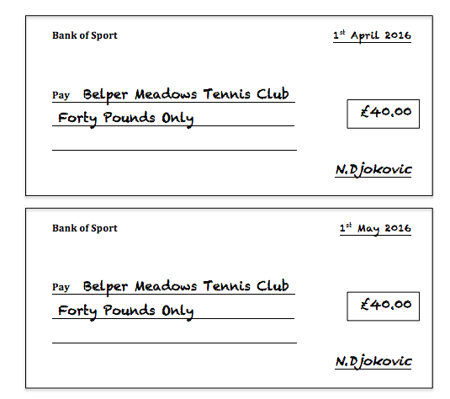

NB. It is important that all post dated cheques are enclosed together for your renewal to be processed.

British Tennis Membership

British Tennis Membership has a number of benefits to you as an individual, such as:
- Entry into the British Tennis Membership Wimbledon ballot
- Aegon British Tennis rating
- Discounts and special offers
- Monthly newsletter

It also has benefits for BMTC, for example the number of Wimbledon tickets the club is allocated depends on the number of our members who are signed up to British Tennis Membership. Also future funding and grants that is available from the LTA may well depend on the size of the club, as measured by signed up members. It doesn’t cost anything to join, so these benefits are all free!

If you are not already a member, we would like to sign you up to British Tennis Membership and to link you to Belper Meadows Tennis Club. Please tick the box below if you do not wish us to do this:

I do not agree to BMTC registering me with British Tennis Membership

Membership Rates

Please complete the following table:

 | Cost | Quantity | Total
Adults | £135
Family (2 adults & 2 juniors 18 or under) | £290
Students living at home | £60
Students living away at university | £40
Non playing members | £10
Under 18 years on 1st Jan 2018 | £70
Under 16 years on 1st Jan 2018 | £60
Under 14 years on 1st Jan 2018 | £50
Under 12 years on 1st Jan 2018 | £40
Under 10 years on 1st Jan 2018 | £30
Under 8 years on 1st Jan 2018 | £20
Under 6 years on 1st Jan 2018  Un | £10
Adults one off Sports Club Fee | £10
GRAND TOTAL

Please tick this box if you do not wish for your email address and telephone numbers to be shared with other members.

Details of Member(s)

Please complete your details below in BLOCK CAPITALS. The information you provide here will ONLY be used by B.M.T.C and will not be passed to third parties. It is very helpful to have up-to-date details for correspondence, particularly email addresses and mobile phone numbers in case we need to contact members at short notice.

Name(s) | Email address | Telephone Number | Postal Address | Date of birth | OFFICE USE ONLY
Home:

Mobile:

Home:

Mobile:

Home:

Mobile:

Home:

Mobile:

Home:

Mobile:

